FLASK + AWS + SNOWFLAKE
Policy Document Intake & Policy Intelligence
Project Documentation · Architecture, Workflow and Implementation
Automated document intake, processing and analytics for insurance policy documents, implemented as a proof of concept (repository: UseCasePOC).
Item | Detail
Project | Policy Document Intake & Policy Intelligence — POC
Stack | Flask 3.0.3, Amazon API Gateway / S3 / EventBridge / Lambda / Textract / DynamoDB / SNS / CloudWatch, Snowflake
Team / organization | Not stated in the provided project materials
Document scope | Based on the uploaded source code, SQL, AWS configuration files, README and architecture diagram

1. Abstract & Executive Summary
Insurance teams receive policy documents as PDFs and images that are difficult to track, read and search. This project implements an end-to-end proof of concept that accepts a policy document through a Flask REST API, stores it in Amazon S3 via an API Gateway proxy, processes it automatically with an AWS Lambda function that uses Amazon Textract, records processing state in DynamoDB, and loads the resulting data into a Snowflake warehouse where it is exposed through curated tables and analytics views.
The solution rests on three ideas:
- Serverless intake — Flask hands each validated document to API Gateway, which writes it to S3 through a native S3 integration, so no upload Lambda or file server is required.
- Event-driven processing — an S3 Object Created event flows through EventBridge to the Document Processor Lambda, which extracts text, classifies the document type and pulls key policy fields.
- Snowflake analytics — a second Lambda, triggered by an SNS completion message, loads processed data into RAW and CURATED tables; ANALYTICS views back search, dashboard and audit outputs.
Every component in the supplied architecture diagram has a counterpart in the repository. Where the diagram left a choice open, the code records an Implementation Assumption, summarised in Section 14.

2. Problem Statement
Policy document handling in insurance operations suffers from several linked problems:
- Manual intake: staff receive and file documents by hand and re-key key details.
- No shared status view: policyholders, agents and customer-service teams cannot easily see whether a document was received, processed or failed.
- Unstructured content: policy numbers, dates and document types remain inside scanned pages rather than queryable fields.
- Fragmented lookup and audit: finding a policy or its documents, and reconstructing what happened to them, requires searching several places.

3. Objectives
- Accept documents securely through authenticated REST endpoints with input validation and a 15 MB size limit.
- Automate extraction: run Textract on each uploaded document, classify its type and extract policy number and effective date.
- Track every document: maintain a status record (UPLOADED, PROCESSED, FAILED) that users can query.
- Centralise analytics: load processed data into Snowflake RAW and CURATED layers with search, dashboard and audit views.
- Stay cost-conscious: use pay-per-request and auto-suspending services suited to a low-volume POC.

4. Proposed System
The proposed system replaces manual triage with a single automated path: Users / Agents call the Flask API; Flask validates the request and forwards the file to API Gateway; S3 stores it; EventBridge triggers the processor; DynamoDB and SNS carry state and events; a loader Lambda writes to Snowflake; and Flask reads policy and search results back from Snowflake. Three user roles are recognised by the login endpoint: policyholder, agent and customer_service.

5. Technology Stack
# | Layer | Technology (from the code) | Responsibility
1 | Client | index.html + app.js (browser), curl, scripts/upload_samples.py | Login, upload, status, lookup and search through the JSON API
2 | API layer | Flask 3.0.3, PyJWT 2.9.0, Gunicorn 22.0.0, python-dotenv | Validation, JWT authentication, metadata, processing trigger
3 | Intake & processing | API Gateway, S3, EventBridge, Lambda (Python 3.12), Textract | Store documents, trigger events, extract and classify
4 | Operational state | DynamoDB (PolicyDocumentProcessing), SNS, CloudWatch | Status tracking, notifications, logs and alarm
5 | Analytics | Snowflake via snowflake-connector-python | RAW landing, CURATED tables, ANALYTICS views
6 | Test & tooling | pytest 8.3.2, moto 5.0.11, Docker | Mocked AWS tests, containerised deployment

6. System Architecture
Figure 1 shows the project's architecture diagram. It contains five zones: (1) Users / Agents, (2) the Flask API layer, (3) AWS document intake and processing, (4) the Snowflake data platform and (5) business outcomes.
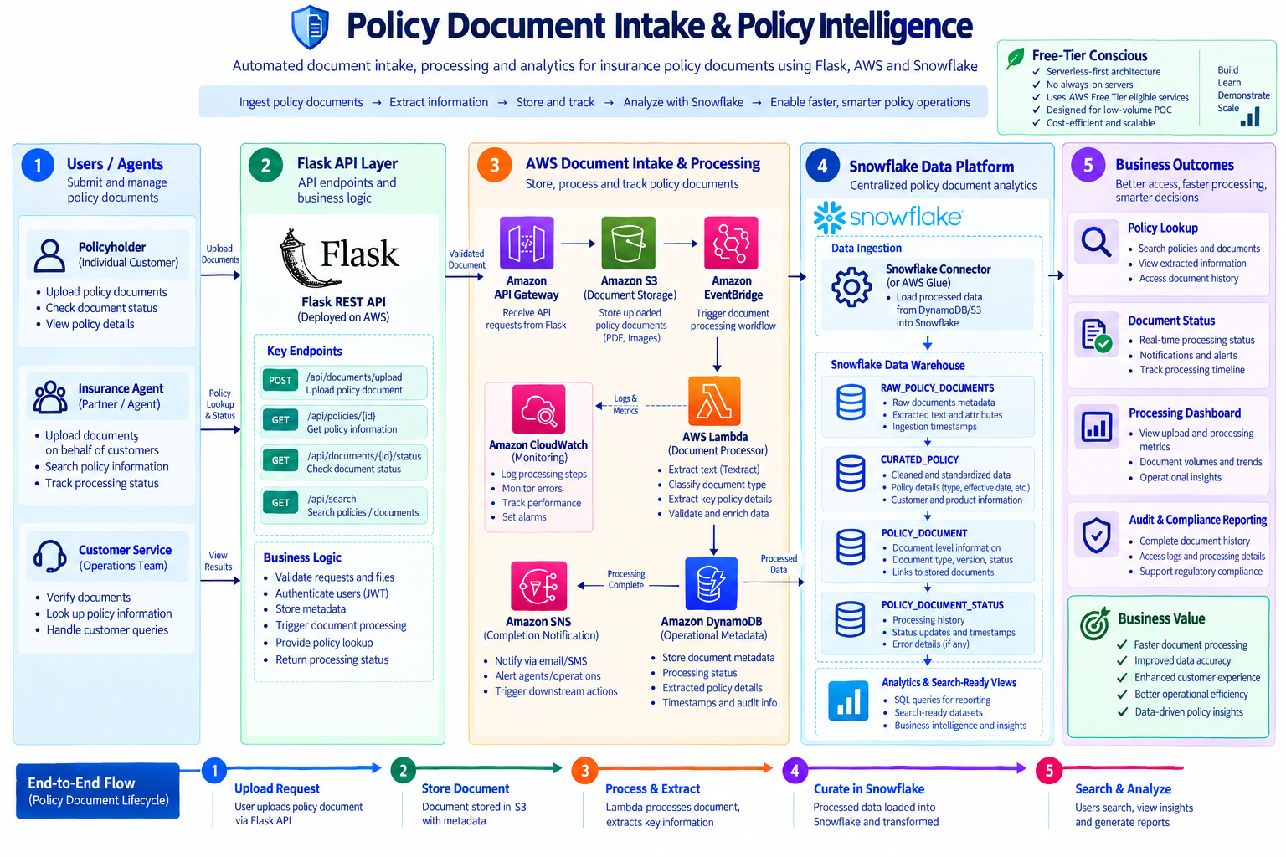
Figure 1 — Policy Document Intake & Policy Intelligence architecture (project diagram)

6.1 Component explanation
- Users / Agents: policyholder, insurance agent and customer-service roles authenticate through POST /api/auth/login and call the API with a Bearer token.
- Flask REST API: an application factory (create_app) registers blueprints for auth, documents, policies, search, health and the browser front end. Routes delegate to services for JWT, AWS and Snowflake.
- Amazon API Gateway: a REST API whose PUT /documents/{proxy+} method uses an AWS-service integration to write objects into S3 using a scoped IAM role.
- Amazon S3: bucket policy-documents-poc, objects under incoming/{customer_id}/{document_id}_{filename}; EventBridge notifications are enabled.
- Amazon EventBridge: rule policy-document-uploaded-rule matches Object Created events for the incoming/ prefix and targets the processor Lambda.
- Lambda — Document Processor: runs Textract, classifies, extracts fields, updates DynamoDB and publishes to SNS.
- DynamoDB, SNS, CloudWatch: operational metadata, completion notification and monitoring (Section 10).
- Lambda — Snowflake Loader: the diagram's “Snowflake Connector (or AWS Glue)” box; the connector option is implemented (Section 11).
- Snowflake: database POLICY_INTELLIGENCE with RAW, CURATED and ANALYTICS schemas.

6.2 Code-to-architecture mapping
Architecture component | Actual code / file | Purpose
Users / Agents | app/routes/auth.py; app/static/app.js | Role-based login; browser client
Flask REST API | app/__init__.py; app/routes/*.py | Blueprints and endpoints
Business logic | app/models/schemas.py; app/services/auth_service.py | Validation; JWT issue and verify
API Gateway → S3 | aws/apigateway/s3-proxy-integration.md; app/services/aws_service.py | Proxy PUT to incoming/ prefix
EventBridge | aws/eventbridge/rule.json | Object Created → processor
Document Processor | aws/lambda/document_processor/handler.py | Textract, classify, extract, update, notify
DynamoDB / SNS / CloudWatch | aws_service.py; aws/setup-commands.md | Status item, topic, error alarm
Snowflake ingestion | aws/lambda/snowflake_loader/handler.py | Load RAW, merge CURATED_POLICY
Snowflake objects | sql/01–04*.sql; app/services/snowflake_service.py | Tables, views, read queries
IAM | aws/iam/*.json | Least-privilege policies per role

7. Detailed Workflow
- Authenticate. The client calls POST /api/auth/login with a username and role and receives an HS256 JWT valid for 60 minutes.
- Validate and upload. POST /api/documents/upload checks the file and customer_id, generates a UUID4 document_id and PUTs the bytes to API Gateway with a 30-second timeout.
- Store. API Gateway writes the object to S3 at incoming/{customer_id}/{document_id}_{filename}.
- Record. Flask writes the initial DynamoDB item (status UPLOADED, document_type UNKNOWN) and returns 202 with the document_id.
- Trigger. S3 emits Object Created to EventBridge; the rule invokes the Document Processor Lambda.
- Process. The Lambda calls Textract detect_document_text, classifies the text and extracts fields with regular expressions.
- Track and notify. The DynamoDB item is updated to PROCESSED (or FAILED with error_details) and an SNS message with event_type document.processed is published.
- Load. The Snowflake Loader Lambda, subscribed to the topic, reads the full item from DynamoDB, inserts a RAW row and merges into CURATED_POLICY.
- Query. Users call GET /api/documents/{id}/status, GET /api/policies/{id} and GET /api/search to retrieve results.

8. Flask API and Backend Architecture
Method | Path | Auth | Backed by | Result
POST | /api/auth/login | No | auth_service.issue_token | 200 + JWT
POST | /api/documents/upload | JWT | API Gateway PUT; DynamoDB put_item | 202
GET | /api/documents/{id}/status | JWT | DynamoDB get_item | 200 / 404
GET | /api/policies/{id} | JWT | CURATED.CURATED_POLICY | 200 / 404
GET | /api/search?q=&limit= | JWT | ANALYTICS.POLICY_DOCUMENT_SEARCH_VIEW (ILIKE) | 200
GET | /api/health | No | — | 200
GET | / | No | templates/index.html | HTML

8.1 Authentication
auth_service.issue_token signs a JWT (HS256) containing sub, role, iat and exp. The require_auth decorator reads the Authorization: Bearer header, verifies the token and stores the claims on flask.g. Expired or malformed tokens raise a 401.
Implementation Assumption (recorded in the code): the diagram calls for JWT authentication but shows no identity provider, so login accepts any username with an allowed role and performs no password check. Replacement with Amazon Cognito or another IdP is noted as a production step.

8.2 Validation, errors and traceability
- Validation: schemas.validate_upload_request requires a non-empty file and customer_id; policy_id is optional. MAX_CONTENT_LENGTH caps uploads at 15 MB (413). ALLOWED_EXTENSIONS is defined in configuration but is not enforced in the validation code.
- Errors: an ApiError hierarchy maps to 400, 401, 404 and 502 responses; unexpected exceptions return a generic 500.
- Tracing: each request receives an X-Request-Id header; Lambda logs include document_id.

9. Data Flow
Input: a PDF or image and a customer_id. Flask passes the file to API Gateway, which stores it in S3. The processor turns the document into a document type and a small set of fields (policy_number, effective_date and a 500-character text excerpt), which are kept in DynamoDB and copied to Snowflake. Output: status and policy responses from Flask, plus SQL-queryable views for search, dashboard and audit.
Client -> Flask -> API Gateway -> S3 -> EventBridge -> Lambda(Textract)
\-> DynamoDB(UPLOADED) |-> DynamoDB(PROCESSED) -> SNS
SNS -> Loader Lambda -> DynamoDB(read) -> Snowflake RAW + CURATED
Flask <- Snowflake (policy lookup, search)

10. AWS Integration
Service | Role in this project
API Gateway | REST API with an S3 proxy integration (type AWS) using role ApiGatewayS3ProxyRole, limited to s3:PutObject on incoming/*. The method itself has authorization type NONE.
S3 | Document storage in bucket policy-documents-poc with EventBridge notifications enabled.
EventBridge | Rule policy-document-uploaded-rule; pattern: source aws.s3, detail-type Object Created, bucket policy-documents-poc, key prefix incoming/.
Lambda + Textract | Function policy-document-processor (Python 3.12, 256 MB, 30 s). Uses detect_document_text. Classifier keywords: AUTO (vehicle, auto insurance, vin), HOME (homeowners, dwelling, property insurance), LIFE (life insurance, beneficiary), otherwise UNKNOWN.
DynamoDB | Table PolicyDocumentProcessing, key document_id, PAY_PER_REQUEST. Stores customer_id, policy_id, s3_key, status, document_type, extracted_data, error_details.
SNS | Topic policy-document-notifications; subscribers are an ops email address and the loader Lambda.
CloudWatch | Lambda log groups with structured messages; alarm document-processor-errors (Errors ≥ 1 over 5 minutes) with the SNS topic as its action.
IAM | Separate policies for Flask (DynamoDB Put/Get), processor, loader and API Gateway, kept in aws/iam/.

11. Snowflake Integration

11.1 Data ingestion
The Snowflake Loader Lambda (policy-snowflake-loader) is triggered by SNS. For each record it reads the DynamoDB item and runs two statements using snowflake-connector-python: an INSERT into RAW_POLICY_DOCUMENTS (extracted_data stored as VARIANT via PARSE_JSON) and a MERGE into CURATED_POLICY keyed on policy_id. If policy_id is empty, document_id is used in its place. AWS Glue is not used; the code records this as an Implementation Assumption.

11.2 Warehouse and schema design
Database POLICY_INTELLIGENCE; warehouse POLICY_WH (XSMALL, AUTO_SUSPEND 60 seconds, AUTO_RESUME, initially suspended).
Schema | Table / view | Columns / purpose
RAW | RAW_POLICY_DOCUMENTS | document_id, customer_id, policy_id, s3_key, document_type, status, extracted_data (VARIANT), ingested_at
RAW | POLICY_DOCUMENT_STATUS | document_id, status, event_timestamp, error_details — processing history
CURATED | CURATED_POLICY | policy_id (PK), customer_id, policy_type, product_name, effective_date, status, updated_at
CURATED | POLICY_DOCUMENT | document_id (PK), policy_id, customer_id, document_type, version, status, s3_key, updated_at
ANALYTICS | POLICY_DOCUMENT_SEARCH_VIEW | Adds search_text (concatenated identifiers) for GET /api/search
ANALYTICS | PROCESSING_DASHBOARD_VIEW | Document counts by document_type, status and day
ANALYTICS | AUDIT_TRAIL_VIEW | Status events ordered by document and time

11.3 Queries and outputs
snowflake_service.py provides get_policy_by_id, search_policies_and_documents, get_processing_dashboard_metrics and get_audit_trail, all using bound parameters. Only the first two are exposed as Flask routes. Test data is provided by sql/04_seed_data.sql and sql/seed/policy_documents_100.csv (100 rows) for the CURATED tables, and by ten generated sample PDFs in sample_documents/ for the real intake path.

12. Security, Cost and Deployment
- Security: no secrets committed (.env ignored), JWT on data routes, IAM policies scoped per component, parameterised SQL, no tokens or passwords logged.
- Cost: DynamoDB on-demand, Snowflake XSMALL with 60-second auto-suspend, S3 proxy through API Gateway (no upload Lambda).
- Deployment: Dockerfile (python:3.12-slim, Gunicorn, 2 workers) and Procfile; the README describes Elastic Beanstalk single-instance deployment but marks it as not yet performed.

13. Testing
The tests/ folder contains eight pytest functions: login token issue, rejection of a bad role, protected-route enforcement, health check, upload success, upload with missing file, status for an unknown document and status after upload. DynamoDB is mocked with moto and the API Gateway call is mocked, so no cloud account is needed.
Test results are not included in the provided materials, and the Lambdas, EventBridge rule and Snowflake queries have no automated tests. The README itself lists the real-AWS workflow, real Snowflake verification and Elastic Beanstalk deployment as not yet completed.

14. Limitations and Implementation Assumptions
- Snowflake schema qualification: the loader connects with default schema RAW yet merges into unqualified CURATED_POLICY (which lives in CURATED). This should be verified or the table name qualified.
- Partial table population: the loader writes RAW_POLICY_DOCUMENTS and CURATED_POLICY only. Population of CURATED.POLICY_DOCUMENT and RAW.POLICY_DOCUMENT_STATUS from the pipeline is not clearly present, although search, dashboard and audit views depend on them.
- Unexposed outputs: dashboard and audit query functions exist without Flask routes.
- Write ordering: Flask writes its DynamoDB record after the S3 upload; a fast Lambda update could be overwritten by the later put_item.
- Shared SNS topic: the CloudWatch alarm uses the same topic the loader consumes; alarm messages lack a document_id.
- Extraction quality: keyword classification and regex extraction are POC-grade.
- Authentication: login has no password store; no HTTPS or CORS configuration; file type is not content-checked; the API Gateway method has no authorizer.
- Front end: the browser page was added beyond the architecture diagram, which draws only the REST API.

15. Future Scope
The following are ideas only and are not implemented:
- Replace open login with Amazon Cognito or another identity provider.
- Qualify Snowflake object names and populate all four tables from the loader; add dashboard and audit routes.
- Use Textract queries / forms or a trained classifier for richer extraction.
- Run end-to-end tests on real AWS and Snowflake accounts; add HTTPS and CORS; deploy to Elastic Beanstalk.

16. Conclusion
The project delivers a coherent, code-backed blueprint for automated policy document intake: an authenticated Flask API, a serverless AWS pipeline that stores, processes and tracks documents, and a Snowflake layer designed for lookup, search and reporting. Its documented gaps are typical of a POC and are largely small, well-scoped fixes, making the repository a sound base for further validation against real cloud resources.

17. References (Project Materials)
- UseCasePOC/README.md; app/ (Flask code); aws/ (Lambda handlers, EventBridge rule, IAM, API Gateway and setup guides); sql/ (schema, tables, views, seed); tests/; Dockerfile and Procfile.
- Architecture diagram: 1.Policy.png (Policy Document Intake & Policy Intelligence).

